Name – Pulkit Chauhan, SAP ID – 500121424, Batch – B1 DevOps

Experiment: Deploying a Containerized Application using AWS ECR and ECS

Objective
To build, push, and deploy a Docker container using AWS Elastic Container Registry (ECR) and Elastic Container Service (ECS).

Prerequisites
- AWS account
- IAM permissions
- Docker installed
- AWS CLI configured

Procedure
Step 1: Login to AWS Console and select region US East (N. Virginia).
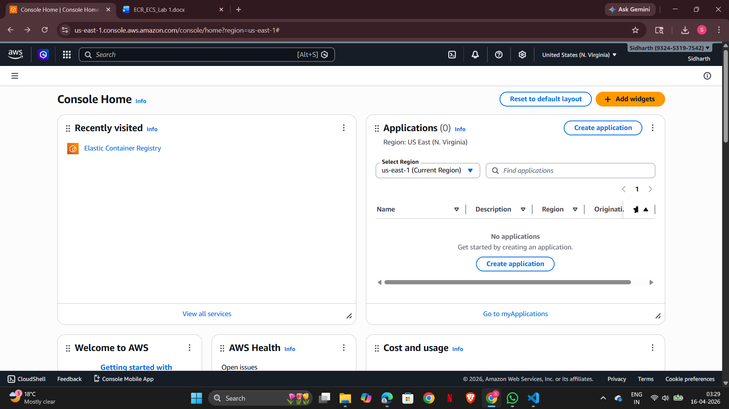

Step 2: Open Elastic Container Registry (ECR) from services.
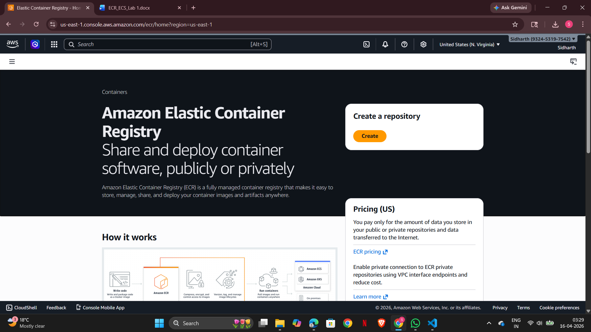
Step 3: Create a new repository with default settings.
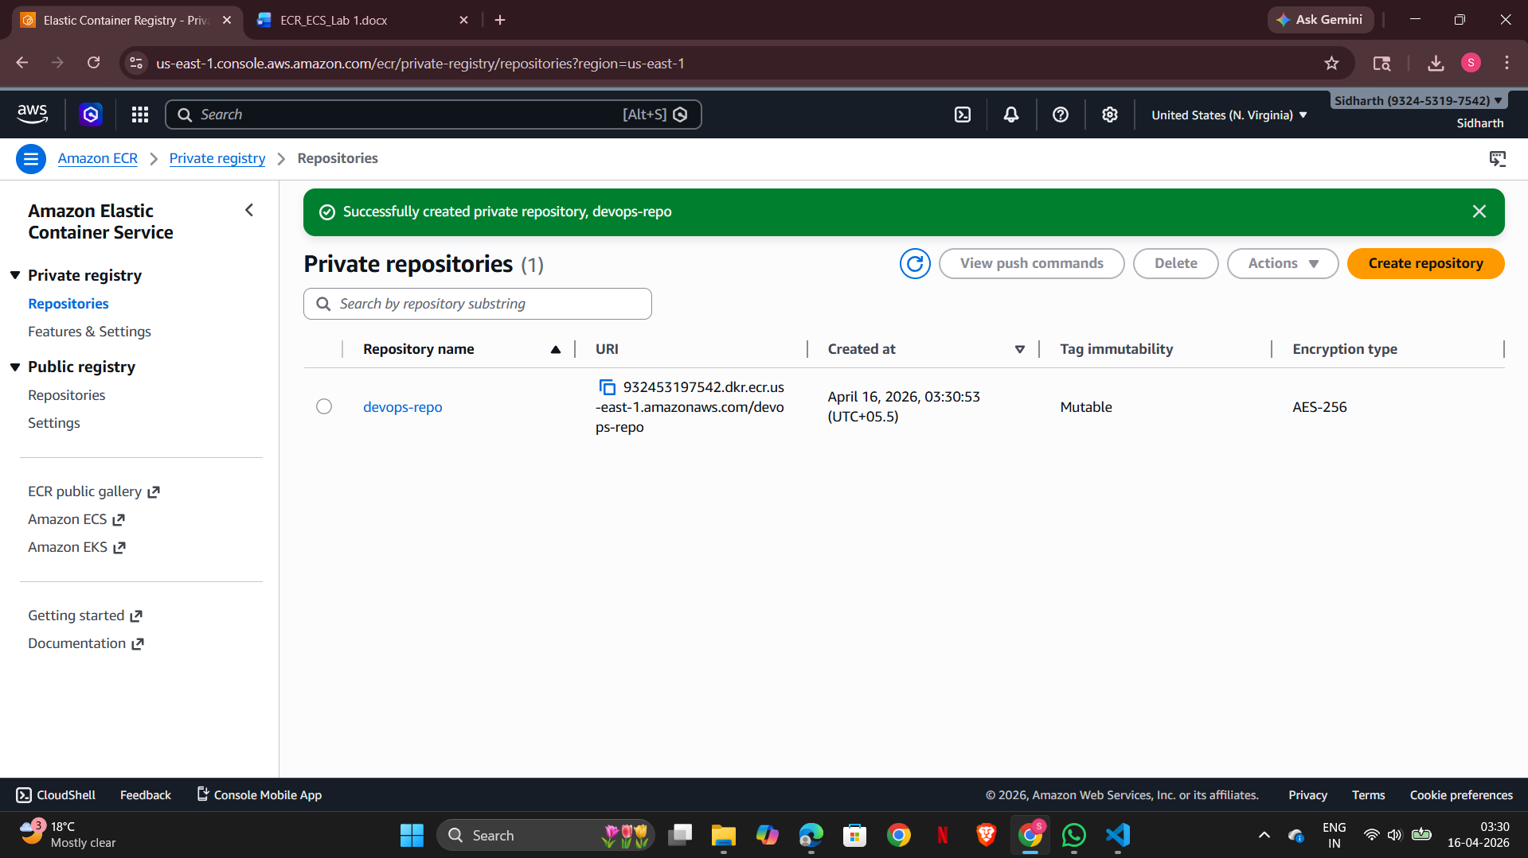

Step 4: Authenticate Docker to ECR using AWS CLI.
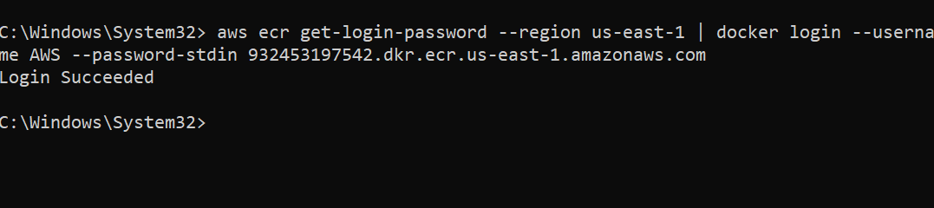
Step 5: Build Docker image using docker build command.
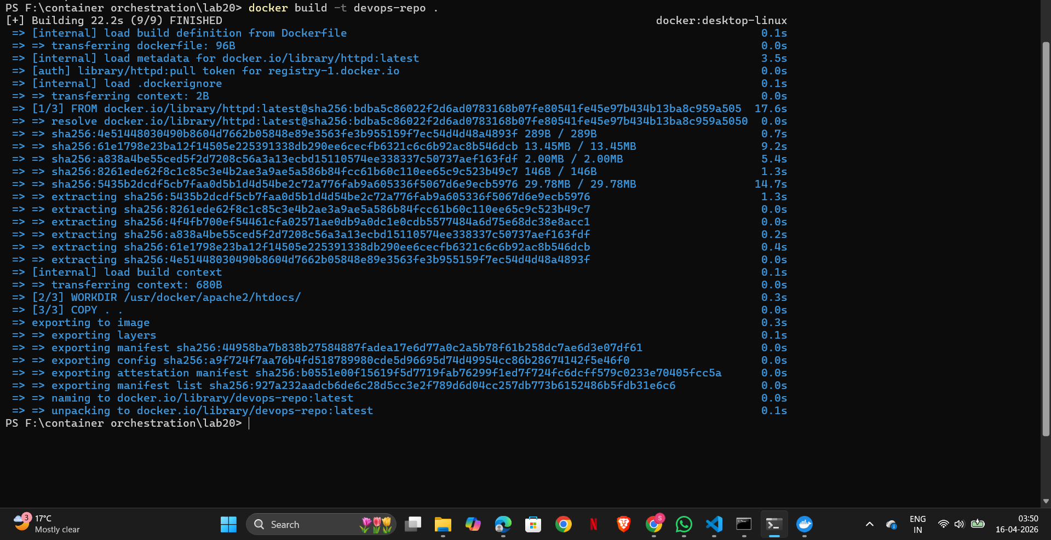
Step 6: Tag the Docker image with repository URI.
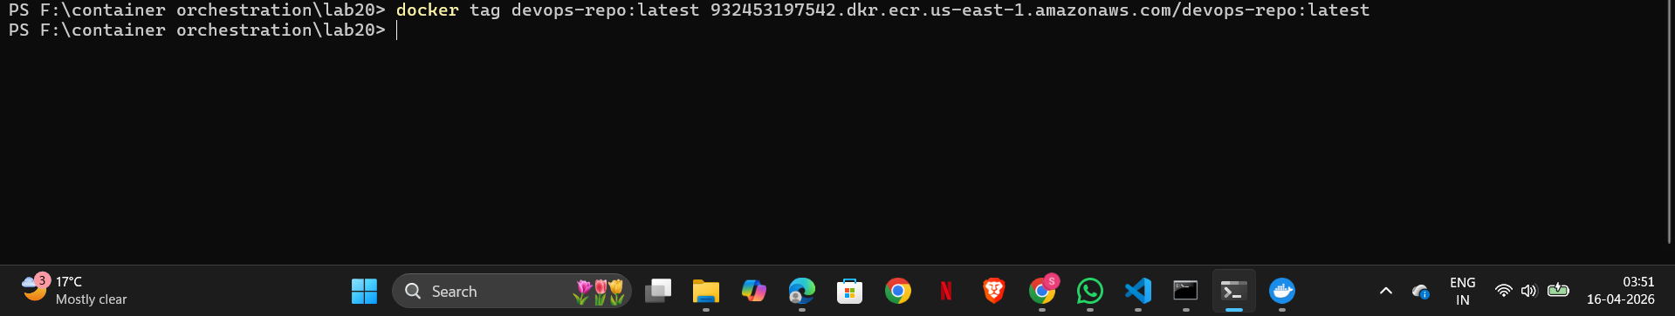
Step 7: Push the Docker image to ECR.
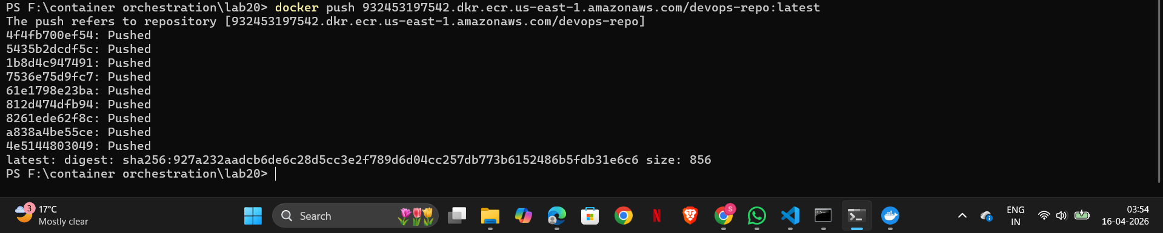
Step 8: Go to ECS and create a new cluster.
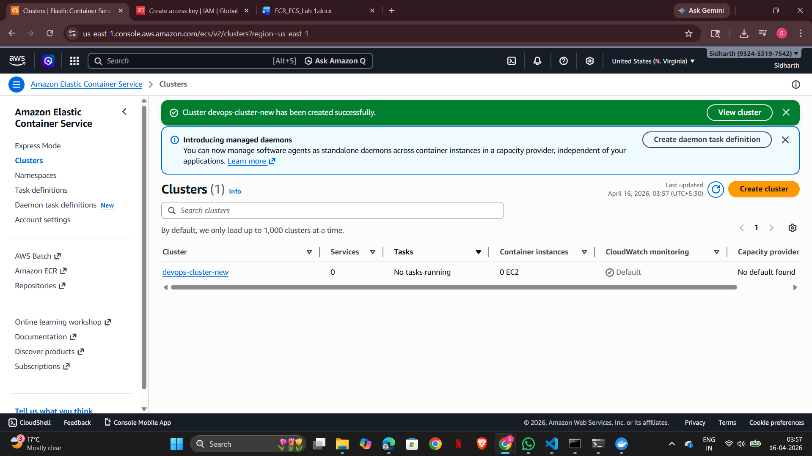
Step 9: Create a task definition and add container using ECR image.
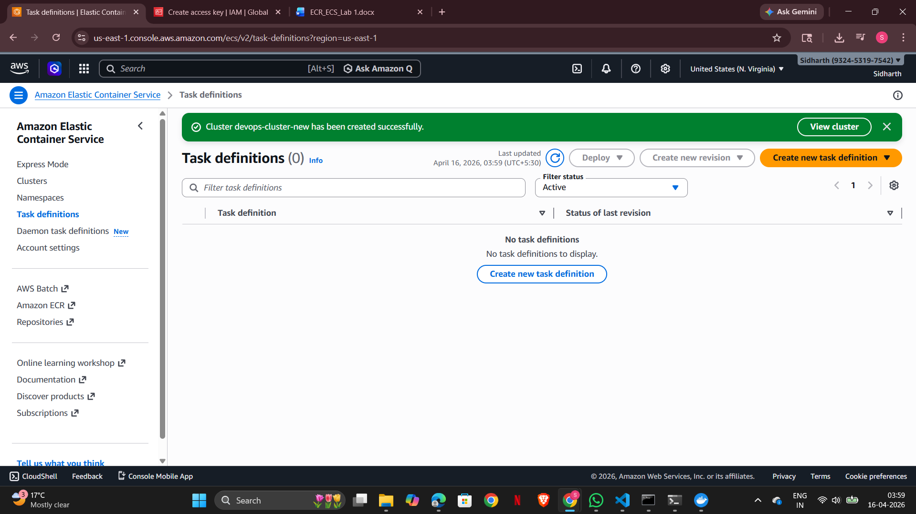
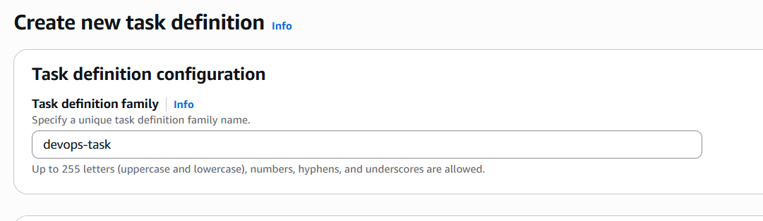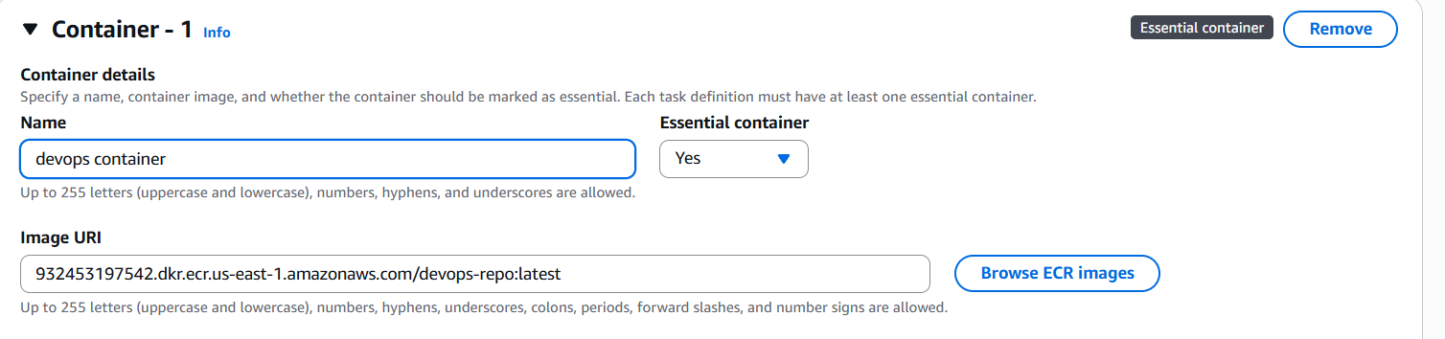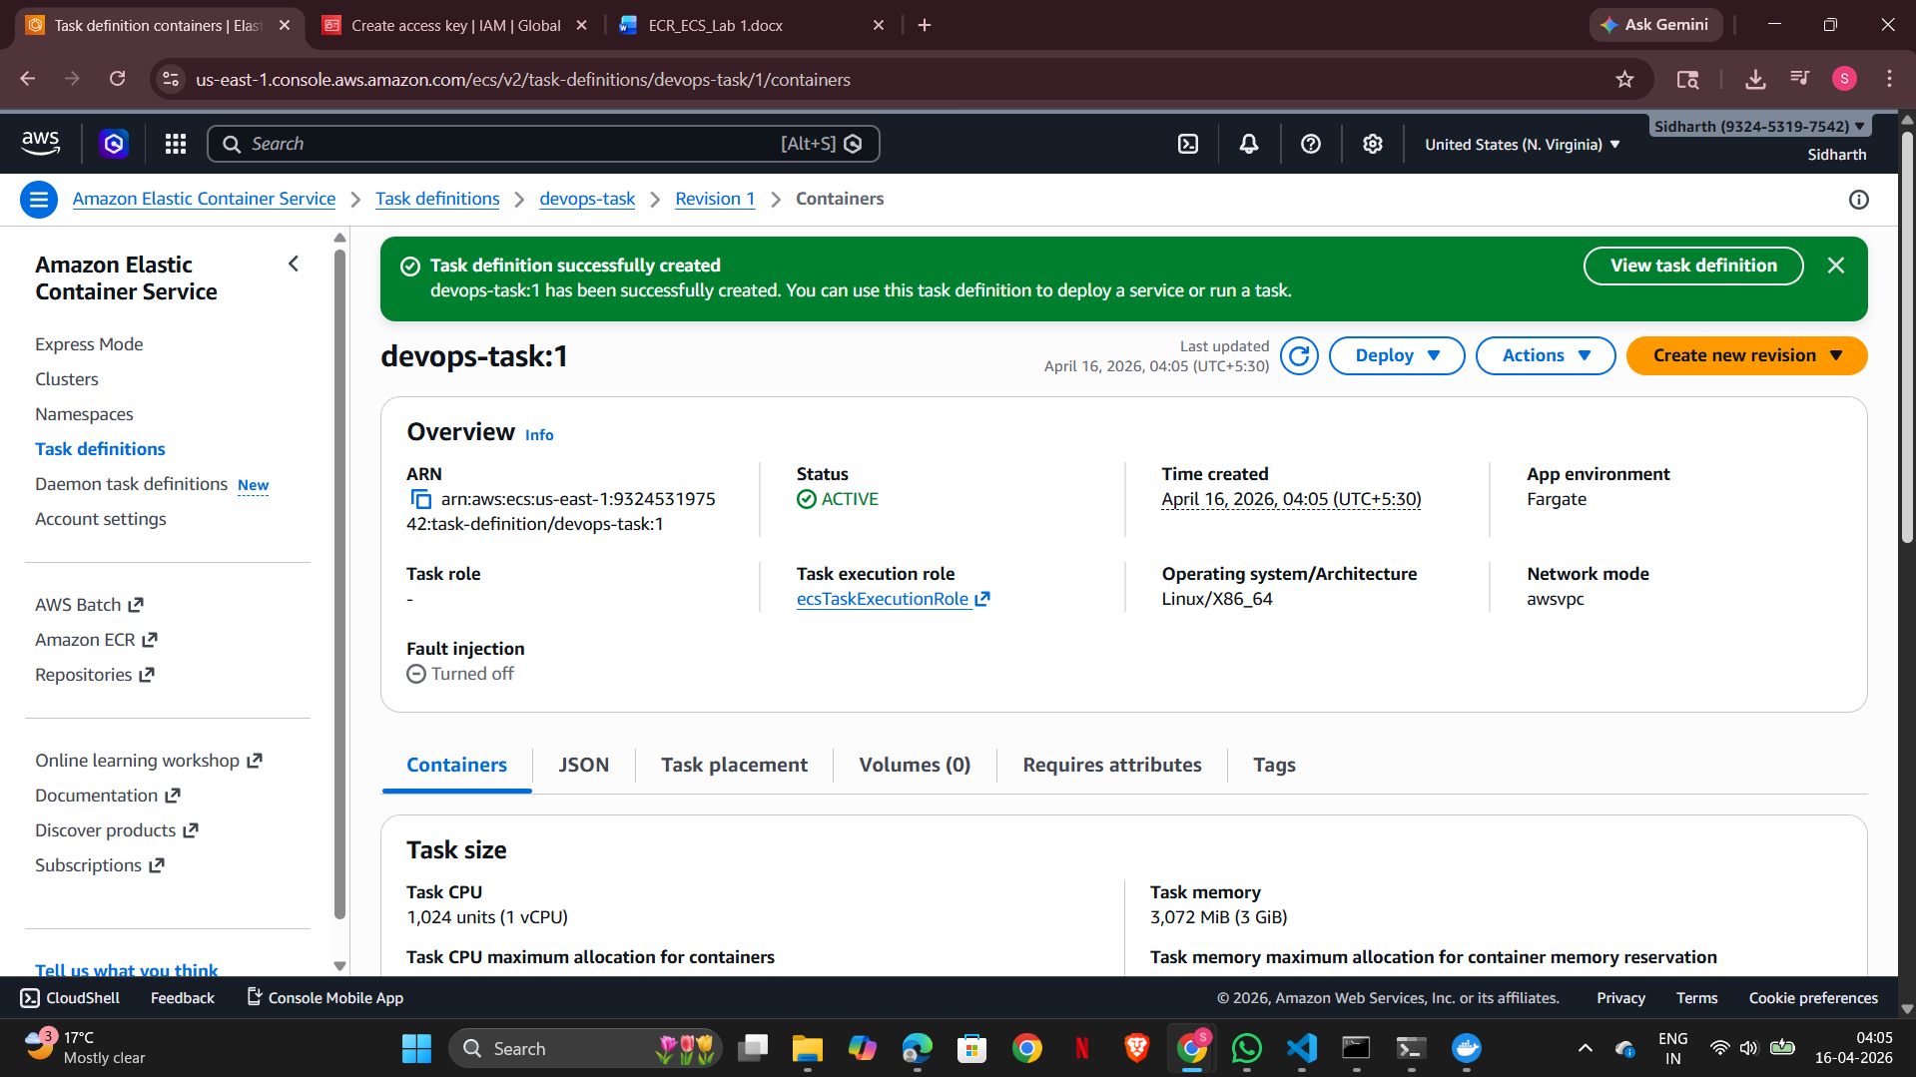

Step 10: Run a service in ECS cluster to deploy container.
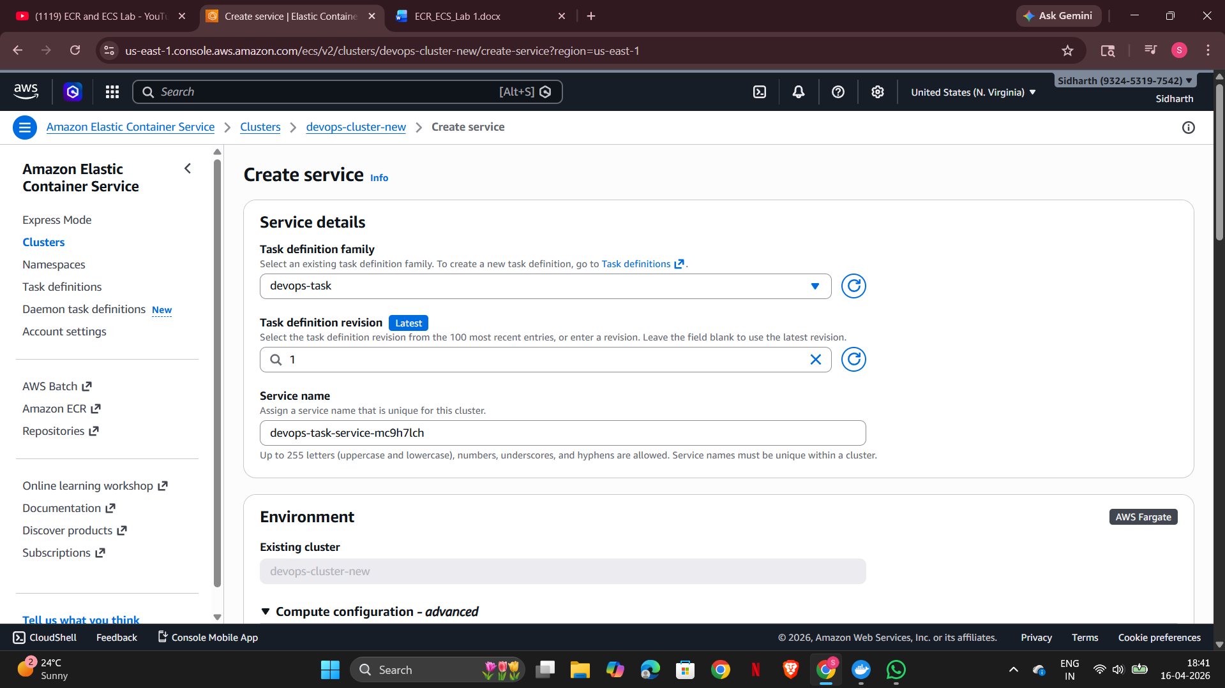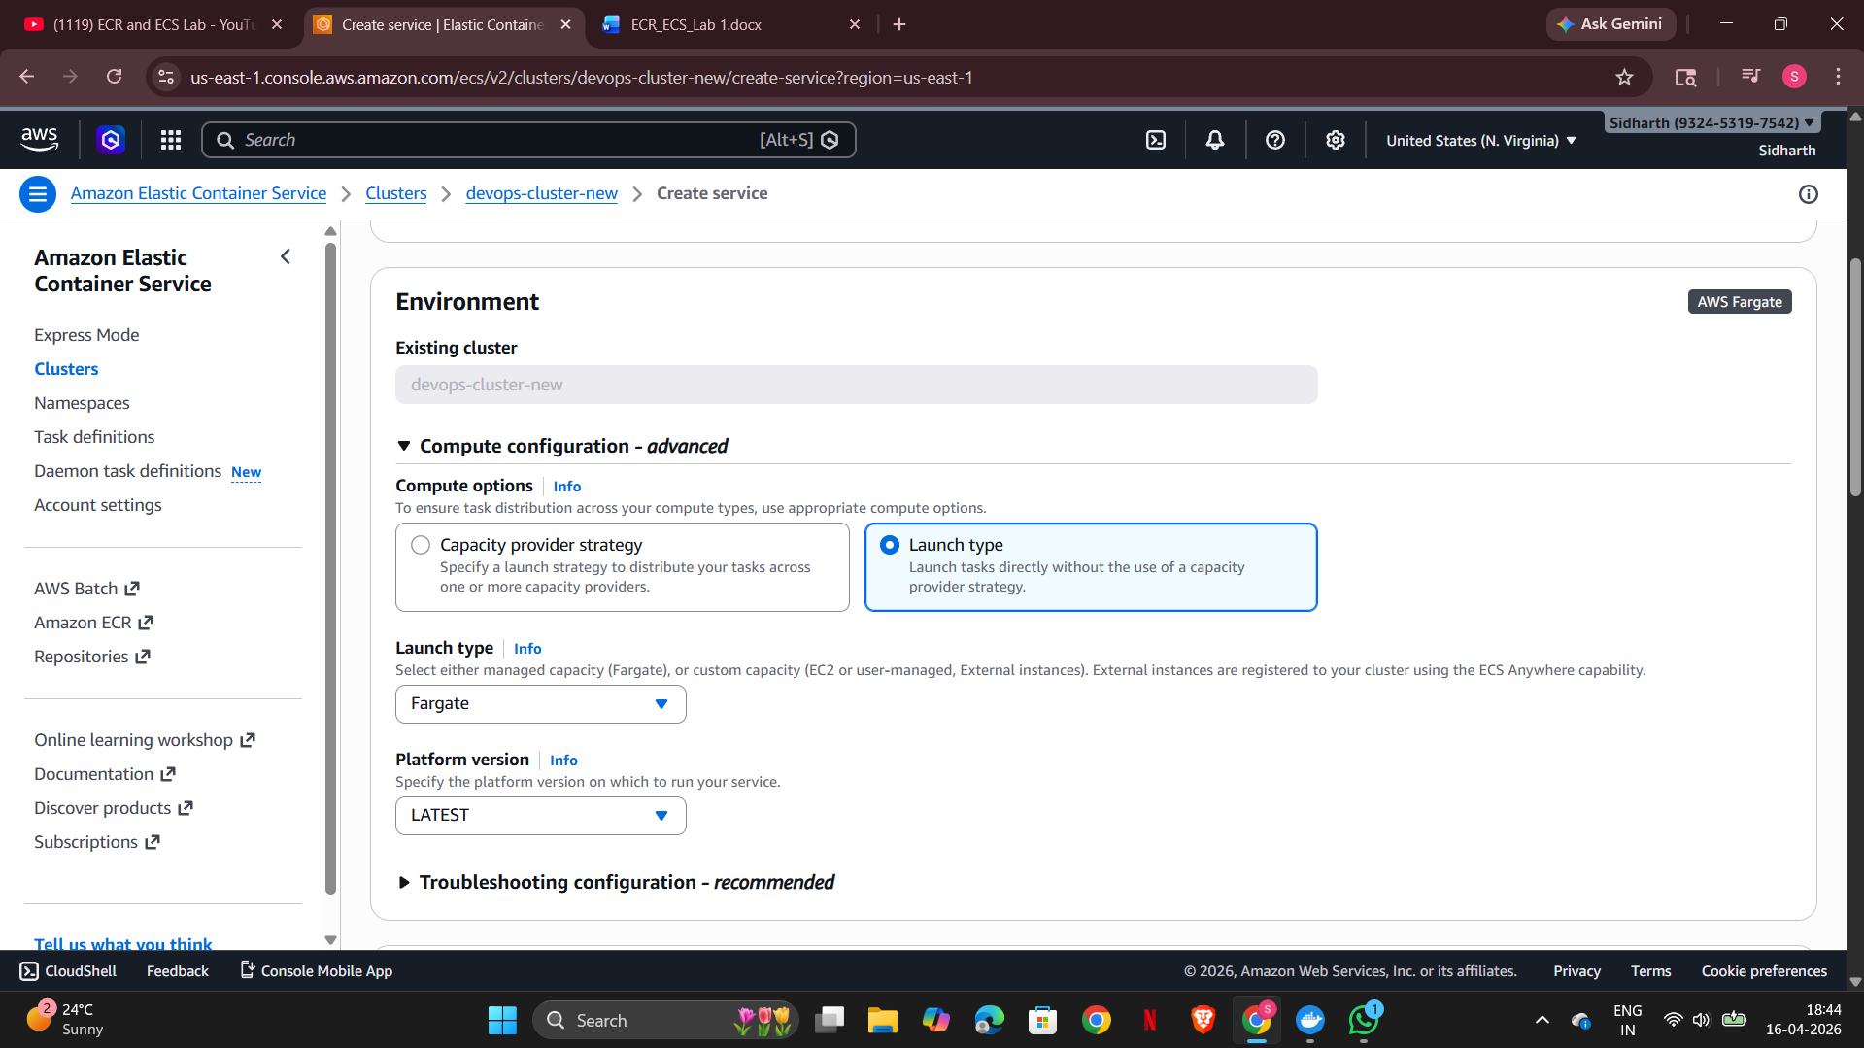

Expected Output
Container runs successfully on ECS.
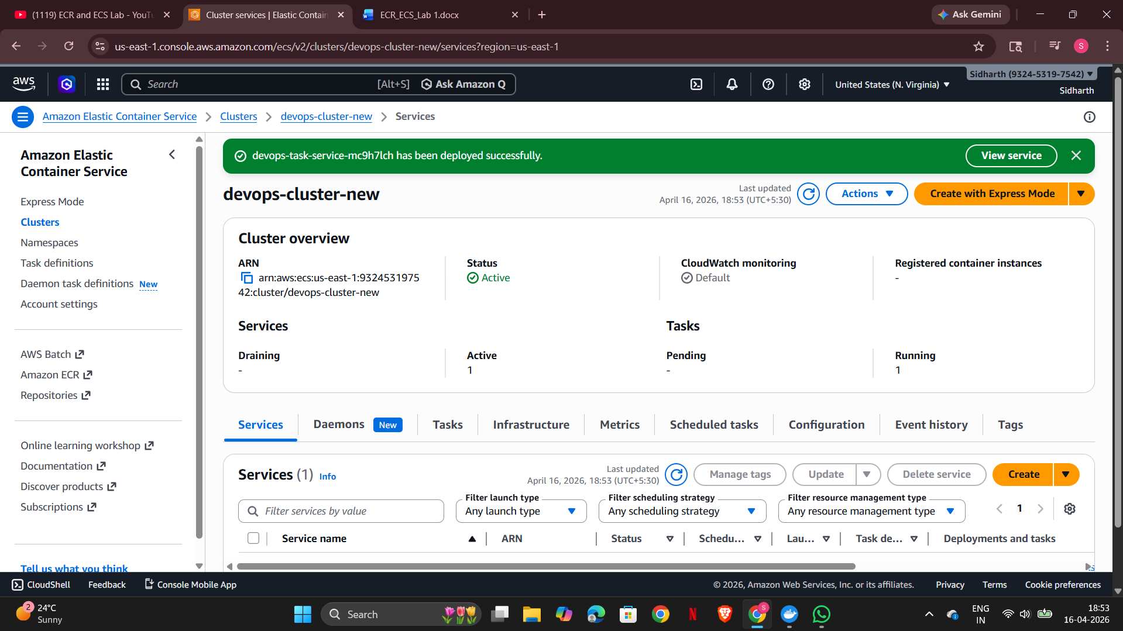

Conclusion
Successfully deployed a containerized application using AWS ECR and ECS.
